**Retail Analysis with Walmart Data**

**DESCRIPTION**

One of the leading retail stores in the US, Walmart, would like to predict the sales and demand accurately. There are certain events and holidays which impact sales on each day. There are sales data available for 45 stores of Walmart. The business is facing a challenge due to unforeseen demands and runs out of stock sometimes, due to the inappropriate machine learning algorithm. An ideal ML algorithm will predict demand at different points of time covering seasonality and ingest factors like economic conditions including CPI, Unemployment Index, etc.

Walmart runs several promotional markdown events throughout the year. These markdowns precede prominent holidays, the four largest of all, which are the Super Bowl, Labor Day, Thanksgiving, and Christmas. The weeks including these holidays are weighted five times higher in the evaluation than non-holiday weeks. Part of the challenge presented by this competition is modeling the effects of markdowns on these holiday weeks in the absence of complete/ideal historical data. Historical sales data for 45 Walmart stores located in different regions are available.

**Dataset Description**

This is the historical data which covers sales from 2010-02-05 to 2012-11-01, in the file Walmart_Store_sales. Within this file you will find the following fields:

* Store - the store number
* Date - the week of sales
* Weekly_Sales -  sales for the given store
* Holiday_Flag - whether the week is a special holiday week 1 – Holiday week 0 – Non-holiday week
* Temperature - Temperature on the day of sale
* Fuel_Price - Cost of fuel in the region
* CPI – Prevailing consumer price index
* Unemployment - Prevailing unemployment rate

Holiday Events  
Super Bowl: 12-Feb-10, 11-Feb-11, 10-Feb-12, 8-Feb-13  
Labour Day: 10-Sep-10, 9-Sep-11, 7-Sep-12, 6-Sep-13  
Thanksgiving: 26-Nov-10, 25-Nov-11, 23-Nov-12, 29-Nov-13  
Christmas: 31-Dec-10, 30-Dec-11, 28-Dec-12, 27-Dec-13

**Analysis Tasks**

**Basic Statistics tasks**

* Which store has maximum sales:

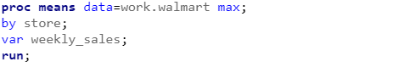

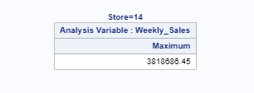

* Which store has maximum standard deviation i.e., the sales vary a lot. Also, find out the coefficient of mean to standard deviation

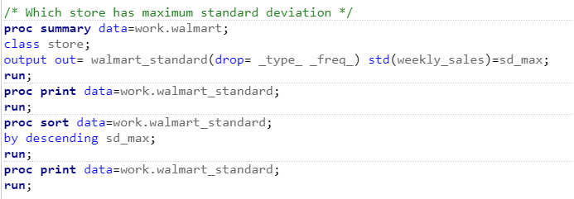

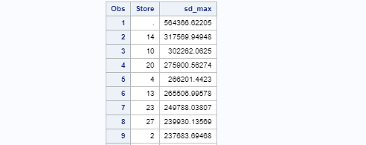

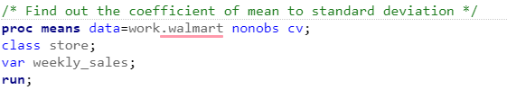

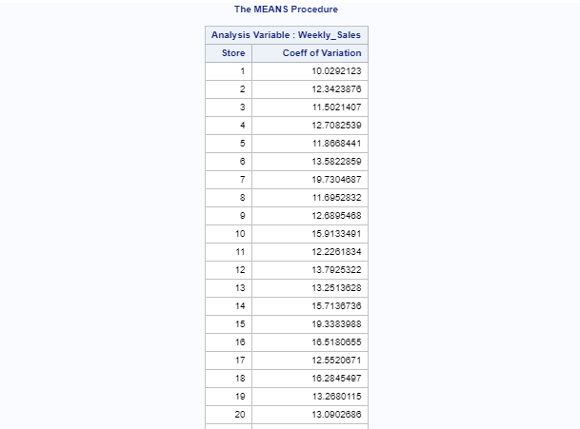

* Which store/s has good quarterly growth rate in Q3’2012

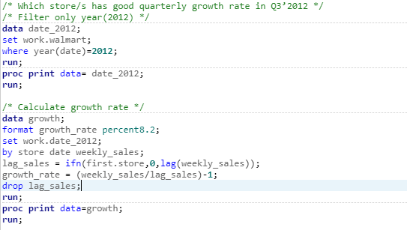

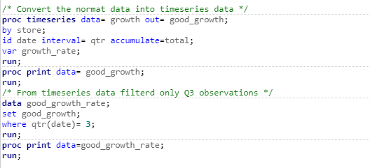

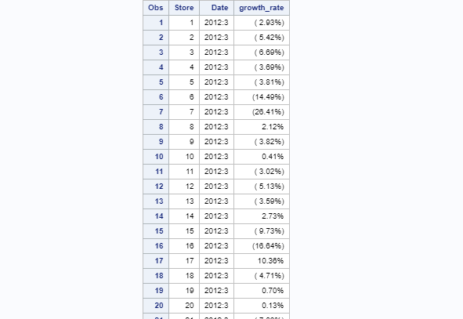

* Some holidays have a negative impact on sales. Find out holidays which have higher sales than the mean sales in non-holiday season for all stores together

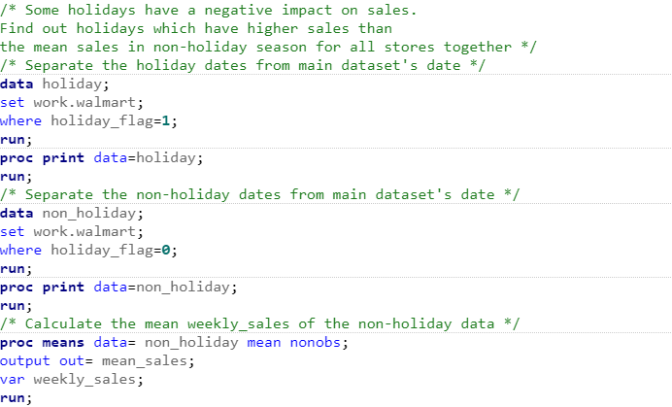

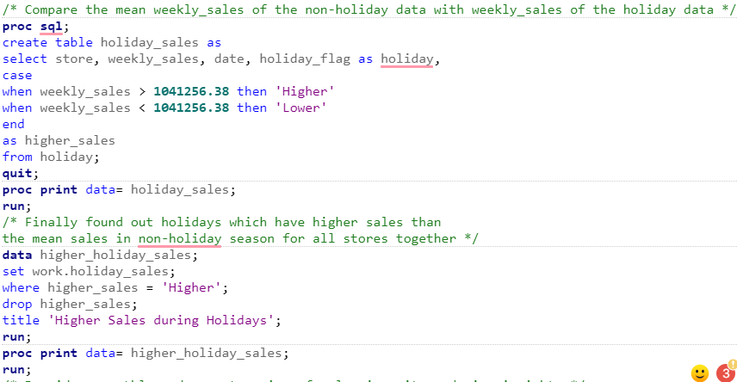

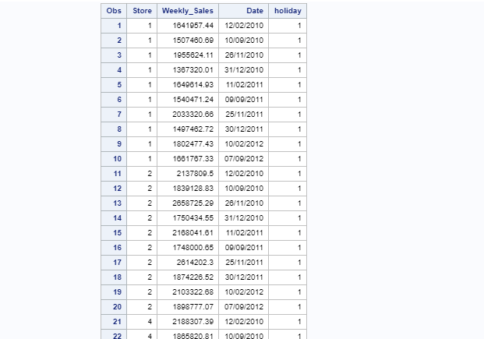

* Provide a monthly and semester view of sales in units and give insights

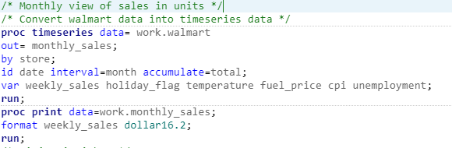

Insights:

Correlation:

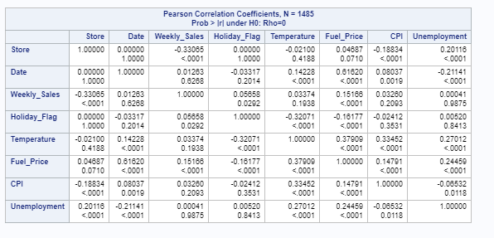

Comparison chart: sales vs store

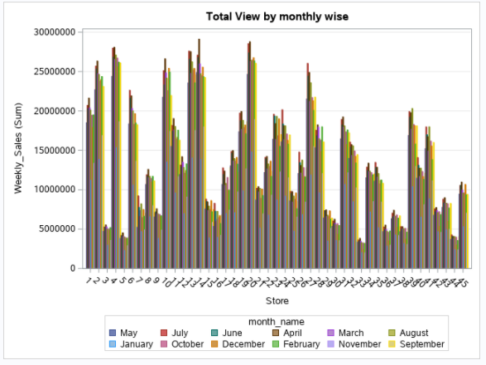

Relationship between store and weekly sales:

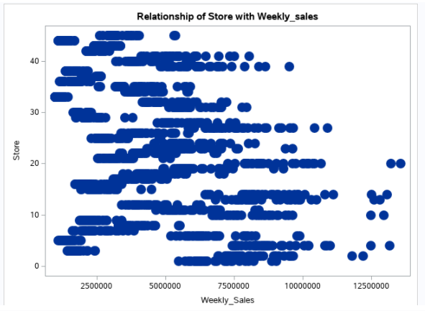

Trends line chart:

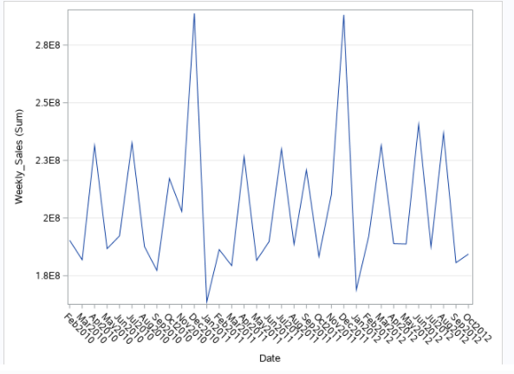

**Semester:**

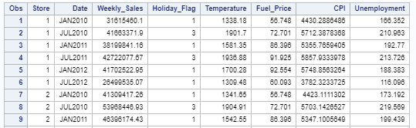

**Correlation matrix:**

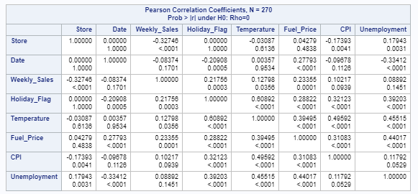

Comparison chart: sales vs store

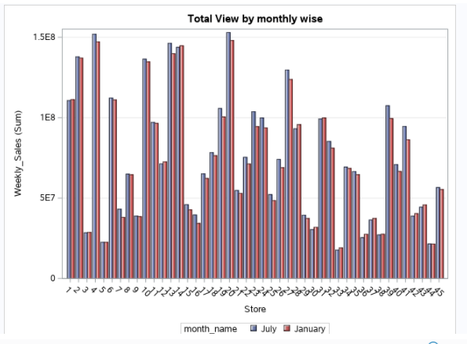

Relationship between store and weekly sales:

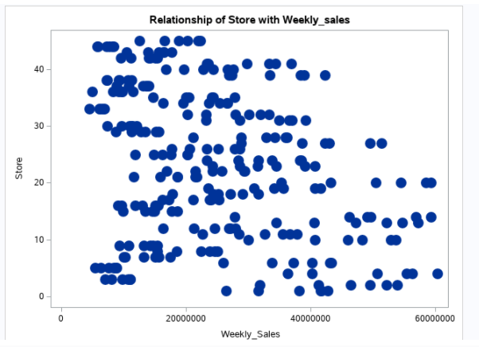

Trends line chart:

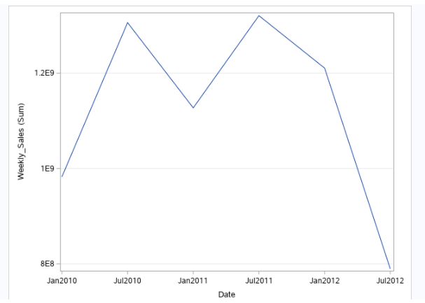

We can Observe from Semester Sales line graph that at beginning of 1st sem of 2010 and 1st sem of 2013 sales are lowest.

**Statistical Model**  
For Store 1 – Build prediction models to forecast demand

* Linear Regression – Utilize variables like date and restructure dates as 1 for 5 Feb 2010(starting from the earliest date in order). Hypothesize if CPI, unemployment, and fuel price have any impact on sales.

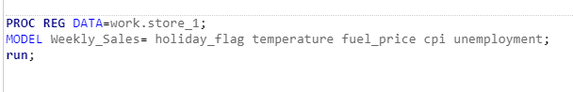

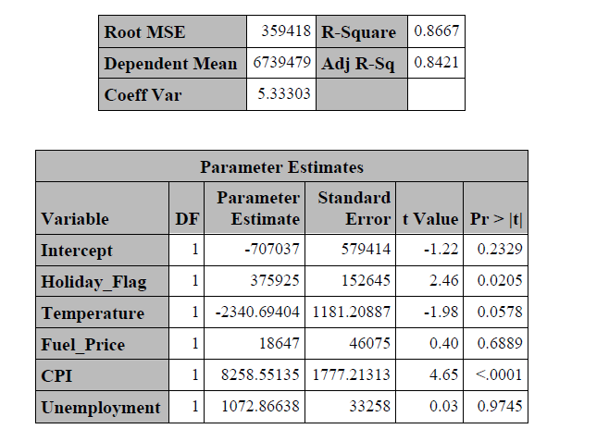

A p-value higher than 0.05 (> 0.05) is not statistically significant and indicates strong evidence for the null hypothesis. This means we retain the null hypothesis and reject the alternative hypothesis. You should note that you cannot accept the null hypothesis, we only reject the null or fail to reject it. So according to the results obtained CPI has p value less than alpha and we retain alternative hypothesis. Fuel_Price and Unemployment has p value greater than alpha so they retain null hypothesis.

* Time series forecasting model –
  + - Hypothesize if the data is fit for time series analysis – check for white noise probability test
    - Make adjustments in historical data for events like holidays, if applicable
    - Build ARIMA model to forecast 6 months i.e., input utilize only till April 2012.
    - Predict next 6 months i.e., June to Oct 2010.
    - Select the model which gives best accuracy.

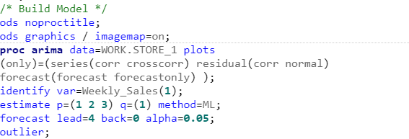

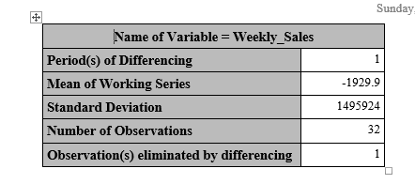

White noise is strongly rejected as the mean is not zero.

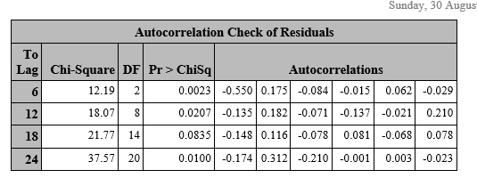

The test statistics rejects the no-autocorrelation hypothesis at a high level of significance (p=0.0023 for first six lags). This means that the residuals are not white noise.

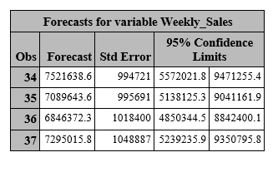

We on using forecast can obtain time series forecasts for next few months.

**The best model is Logistic regression.**

**The results of logistic and arima are attached in screenshot section (submission process).**